**A PROJECT REPORT**

**ON**

**“Stock Management System” Submitted To:**

**PRODEVANS TECHNOLOGIES PVT.LTD **

**Under the Guidance of**

**Mrs.KAJAL MISHRA**

**Submitted by:**

**AKASH THAKUR**

**ASHIS KUMAR NAHAK**

**MALHAAR MAHAPATRO**

**PRAJAKTA MAGAR**

Stock Management Project|

**STOCK MANAGEMENT SYSTEM**

**1.1 ABSTRACT:**

Stock management software tracks, manages, and organizes stock levels, orders, sales, and deliveries. The purpose of stock management software is to maintain an optimal stock level, track goods during transport between locations, receive new items, manage warehouse processes such as picking, packing, and shipping, prevent product obsolescence and spoilage, and ensure your products are never out of stock.

Software for stock management automates what used to be a time-consuming, manual process of counting each item one by one and recording it on paper.

Digitizing this process not only makes it more accurate, it saves valuable time.

**1.2 INTRODUCTION:**

The project Stock Management System is a complete desktop based application designed on Net technology using EclipseIde Software. The main aim of the project is to develop Stock Management System Model software in which all the information regarding the stock of the organization will be presented. It is an Intranet based desktop application which has an admin component to manage the stock and maintenance of the stock system.

This desktop application is based on the management of stock of an organization. The application contains general organization profile, sales details, Purchase details and the remaining stock that are presented in the organization.

Each new stock is created and entitled with the name and the entry date of that stock and it can also be updated any time. Here the login page is created in order to protect the management of the stock of the organization in order to prevent it from the threads and misuse of the stock.

**Page**| 2

Stock Management Project|

**1.3 Project Category: Web-Based Application**

**1.3.1 Available Technologies:**

**Languages:** Jsp, Java

**RDBMS:** MySQL

**Web Server:** Apache Tomcat server

**Development Platform:** Eclipse

**1.3.2 Tools Used:**

**Editor Used:** Eclipse, Apache Tomcat server for MySQL **Operating System:** Windows XP/7/8/10/11

**1.3.3 Hardware Used:**

**Processor:** Intel corei3

**RAM:** 2GB

**Hard Disk:** 1TB

**Page**| 3

Stock Management Project|

2. Application Architecture

We have used Layered Architecture in the Project.

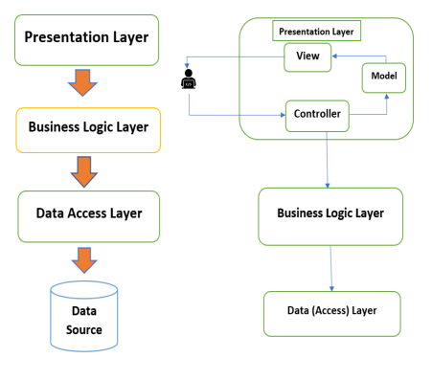**Fig 2.1 Layered Architecture**

**Page**| 4

Stock Management Project|

3. Use Case Diagram:

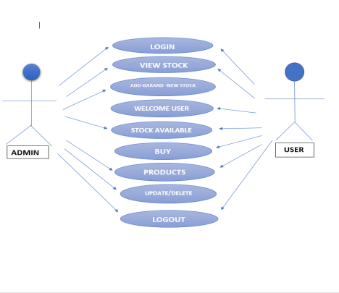**Fig 3.1 Use case Diagram**

**Page**| 5

Stock Management Project|

4. ER-DIAGRAM:

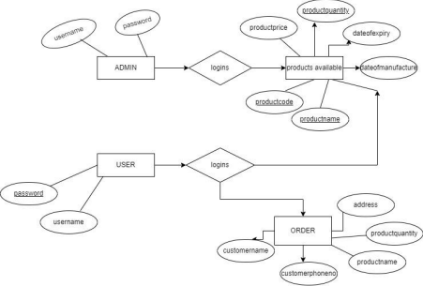**Fig 4.1 ER Diagram**

**Page**| 6

Stock Management Project|

**5. UML DIAGRAM**

**5.1 CLASS DIAGRAM:**

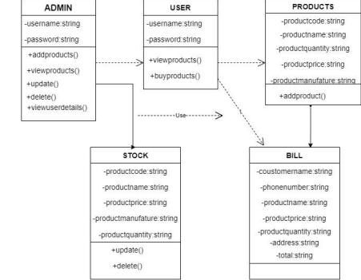**Fig 5.1 Class Diagram**

**Page**| 7

Stock Management Project|

**5.2 SEQUENCE DIAGRAM:**

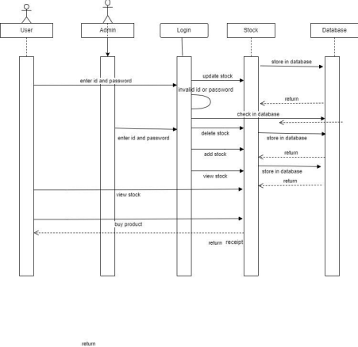**Fig 5.1 Sequence Diagram Page**| 8

Stock Management Project|

6. DATA FLOW DIAGRAM(DFD): 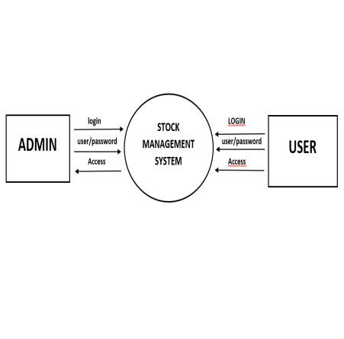

**Fig:6.1 DFD - LEVEL-0**

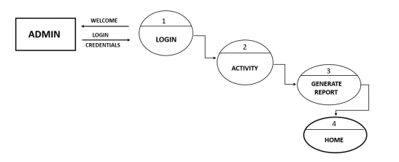**Fig: DFD - LEVEL-1 for Admin**

**Page**| 9

Stock Management Project|

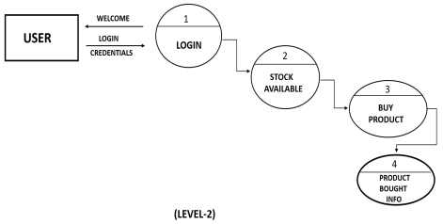**Fig: DFD - LEVEL-1 for User**

Project Structure:

Stock Management

- stock_management.Controller

- stock_management.Dao

- stock_management.Model

- stock_management.Utilities

**Page**| 10

Stock Management Project|

CONNECTION TO DATABASE:

**QUERIES**

**#Query to create the database**

create database stock_management;

use stock_management;

**#Query to create the Product Table**

create table product (product_code varchar(255) primary key, product_name varchar(255),

product_price varchar(255),

product_quantity varchar(255),

date_of_manufacture date,

date_of_expiry date);

**#Query to Insert in the Product Table**

insert into product values('101','Bag',1500, 2,'5.4.2022','20.10.2022'); insert into product values('102','Pen',50, 1,'5.04.2021','20.11.2022'); insert into product values('103','FlowerPot',550, 12,'03.04.2022','02.03.2025');

SELECT * FROM PRODUCT;

**#Query to Register User Table**

create table register(username varchar(255),

password varchar(255),

first_name varchar(255),

last_name varchar(255),

address varchar(255),

**Page**| 11

Stock Management Project|

phone_no varchar(255),

email_id varchar(255));

**#Query to Insert in the Register User Table**

insert into register values( ‘Akash’,'123','AKASH',’THAKUR’, ’Kalaburagi.Karnataka’,’9019596952’,’akashrthakur786@gmail.com’);

SELECT * FROM REGISTER;

**#Query to Customer Order Table**

create table customer(customer_id int primary key not null auto_increment, customer_name varchar(255),

phone_no varchar(255),

address varchar(255),

product_name varchar(255),

product_quantity varchar(255));

**#Query to Insert Customer Order Table**

insert into customer (customer_name, phone_no, address, product_name, product_quantity) values ("praju","561121","kalyan","soap","3");

SELECT * FROM CUSTOMER;

**Page**| 12

Stock Management Project|

**Home Screen:**

<body>

<nav class="navbar navbar-expand-lg navbar-dark bg-dark">

<div class="container">

<a class="navbar-brand text-center" href="Index.jsp"

style="margin: 0 auto;">

<i class="fa fa-opencart">

</i> Welcome To Stock Management

</a>

</div>

</nav>

<table class="tab hd brown" >

<tr>

<td>Admin LOGIN</td>

</tr>

</table>

<table class="tab" border="1" cellpadding="20" cellspacing="20" align="left">

<tr>

<td>

<%-- The form data will be passed to validate.jsp for validation on clicking submit --%>

<form method="get" action="ValidateUser.jsp">

Enter Username : <input type="text" name="user" required><br /> <br /> Enter Password : <input type="password" name="pass"

required><br /> <br /> <input type="submit" Onclick="validate()" value=" LOGIN "><br />

</form>

</td>

</tr>

</table>

</body>

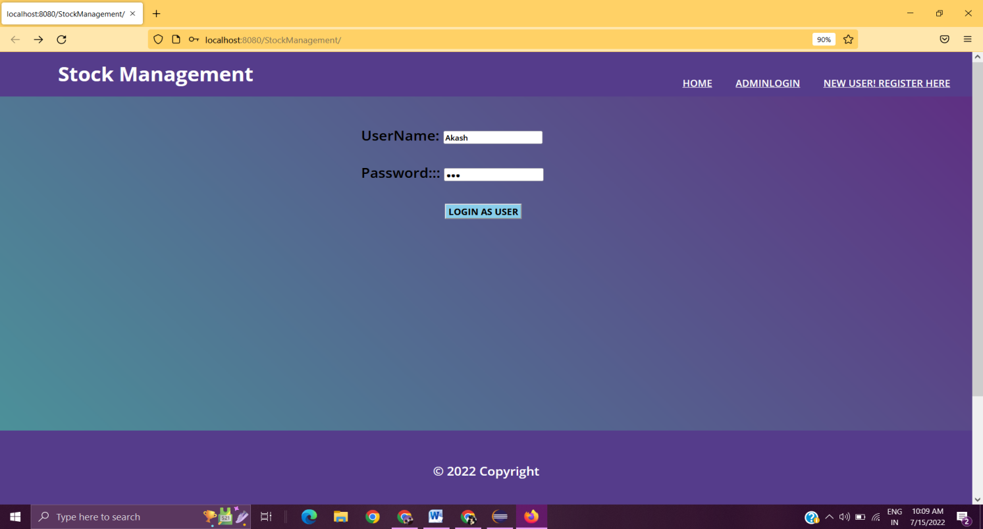

**Fig 6.1 Home Page**

**Page**| 13

Stock Management Project|

**ADMIN LOGIN:**

<br>

<div class="LOGOUT">

<a href="http://localhost:8080/StockManagement/Index.jsp">

<button type="button" class="btn btn-success">LOGOUT</button> </a>

</div>

</br>

<div class="LOGOUT">

<a href="http://localhost:8080/StockManagement/Retrive.jsp"> <button type="button" class="btn btn-danger">View Products</button> </a>

</br>

<br>

<div class="home">

<a href="http://localhost:8080/StockManagement/User.jsp">

<button type="button" class="btn btn-info"> USER DETAILS</button> </a>

</div>

</br>

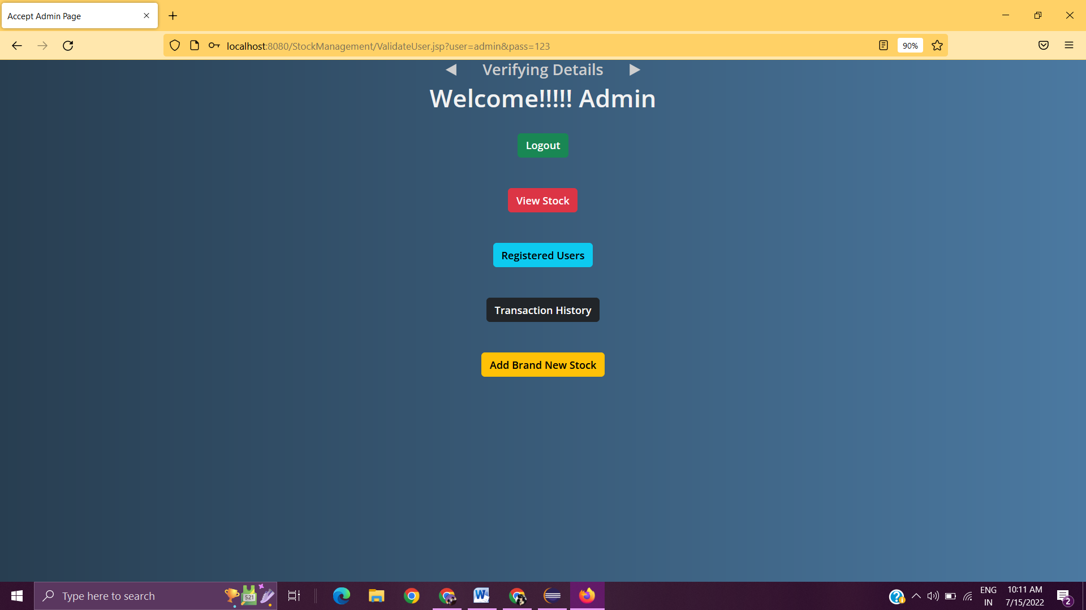 **Fig 6.2 Admin Verified**

**Page**| 14

Stock Management Project|

**VIEW PRODUCTS:**

<td><%=resultSet.getString("productcode") %></td>

<td><%=resultSet.getString("productname") %></td>

<td><%=resultSet.getString("productprice") %></td>

<td><%=resultSet.getString("productquantity") %></td>

<td><%=resultSet.getString("dateofmanufacture") %></td>

<td><%=resultSet.getString("dateofexpiry") %></td>

<td>

<a href =

Update.jsp?productcode=<%=resultSet.getString("productcode")%> <button type="button" class="btn btn-success">UPDATE</button> </a>

</td>

<td>

</a>

</td>

</tr>

<%

}

connection.close();

} **catch** (Exception e) {

e.printStackTrace();

}

%>

</table>

</table>

</body>

</html>

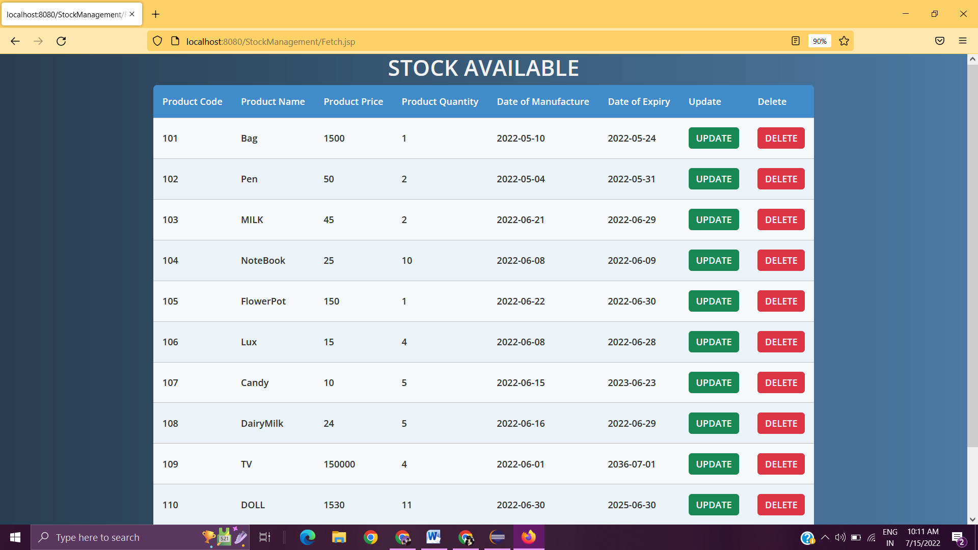 **Fig 6.3 Stock Available**

**The admin can view products and also he has the access to update and delete the products.**

**Page**| 15

Stock Management Project|

**ADD NEW PRODUCTS:**

<table class="tab" border="0px" cellpadding="10" cellspacing="10" text-color="red">

<tr>

<td>

<form action="<%= request.getContextPath() %>/register"

method="post">

Product_Code :

<input type="text" name="productcode" required><br />

<br />

Product_Name : <input type="text" name="productname"

required><br />

Product_Price: <input type="text" name="productprice"

required><br />

<br />

Product_Quantity : <input type="text"

name="productquantity" required><br />

<br />

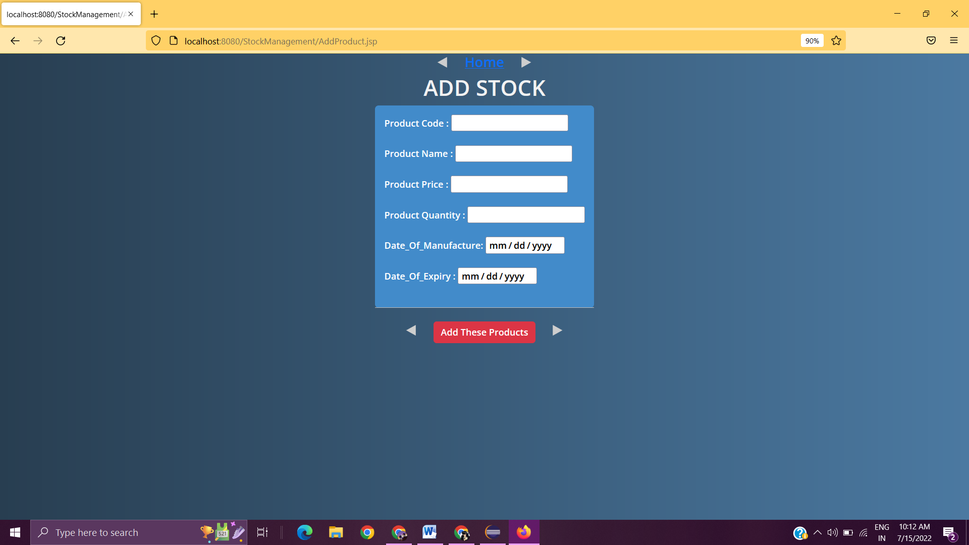 **Fig 6.4 Add Stock**

Admin adds brand new stock which can be viewed by admin as well as registered users.Only Admin has the ability to add brand new stock and the data is stored in database.

**Page**| 16

Stock Management Project|

**USER REGISTRATION FORM:**

*<body>*

*<div id="topmid">*

*</div>*

*<div class="home">*

*<a href="http://localhost:8080/StockManagement/Index.jsp">HOME</a> </div>*

*<table class="tab brown hd">*

*<form action="<%=request.getContextPath()%>/registername" method="post"> Username : <input type="text" name="username"required><br/><br/> Password : <input type="password" name="password"required><br/><br/> FirstName: <input type="text" name="firstname"required><br/><br/> Last Name: <input type="text" name="lastname"required><br/><br/> Address : <input type="text" name="address"required><br/><br/> Phone No : <input type="text" name="phone"required><br/><br/> Email Id : <input type="text" name="mailid"required><br/><br/> <input type="submit"></button>*

*</form>*

*</td>*

*</tr>*

*</table>*

*</body>*

*</html>*

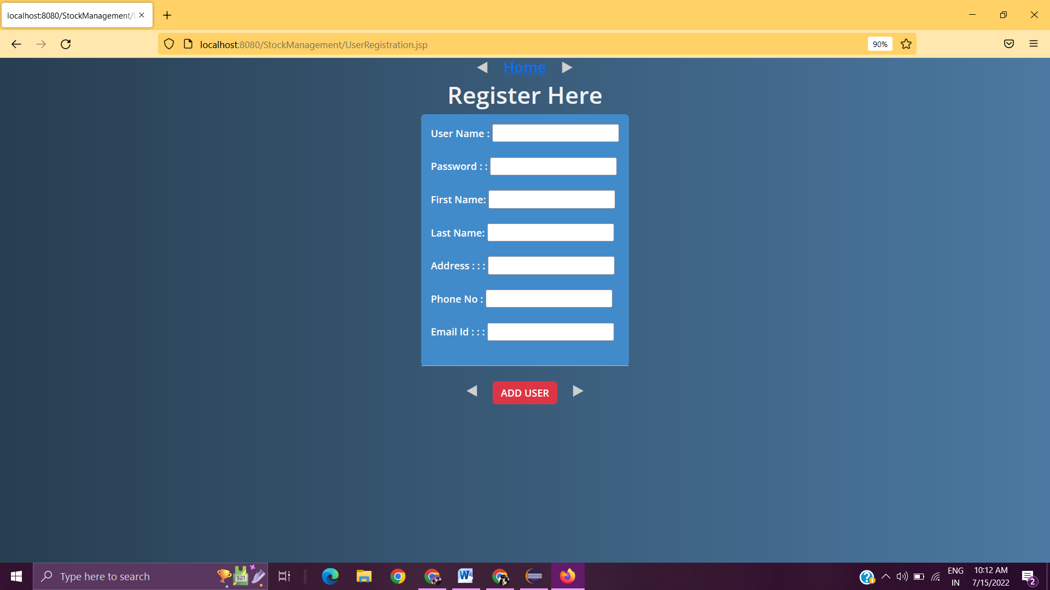**Fig 6.5 New User Registration**

This form is used for registration of a new user so that he can login and see the products available.

**Page**| 17

Stock Management Project|

**BUY PRODUCTS:**

*<body>*

*<div align="center">*

*<h1>Buy Product</h1>*

*<table style="with: 80%">*

*<form action="New.jsp" method="GET">*

*<tr>*

*<td>customername</td>*

*<td>*

*<input type="text" name="customername" required><br />*

*</tr>*

*<tr>*

*<td>phoneno</td>*

*<td>*

*<input type="text" name="phoneno" required><br />*

*</tr>*

*<tr>*

*<td>address</td>*

*<td>*

*<input type="text" name="address" required><br />*

*</tr>*

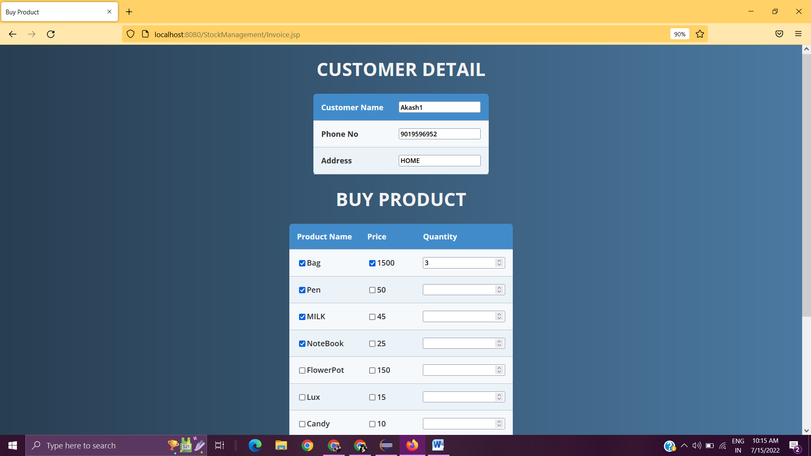**Fig 6.5 Buy Product**

**Page**| 18

Stock Management Project|

Here the user buys the product and selects how much quantity he wants to buy and it redirects to the next page for accounting.

**Invoice:**

<!DOCTYPE html>

<html>

<head>

<meta http-equiv="content-type" content="text/html;

charset=ISO-8859-1">

<title>JSP Page</title>

</head>

<body>

<h1>product bought info</h1><b>customername:</b>

<%= request.getParameter("customername")%> <br>

<b>phoneno</b>

<%= request.getParameter("phoneno")%> <br>

<b>address</b>

<%= request.getParameter("address")%> <br>

<b>productname:</b>

<%= request.getParameter("productname")%> <br>

<b>productprice:</b>

<%= request.getParameter("productprice")%> <br>

<b>productquantity:</b>

<%= request.getParameter("productquantity")%> <br>

<b>Total:</b>

<%=

Integer.parseInt(request.getParameter("productquantity"))*Integer.pars eInt(request.getParameter("productprice"))%> <br>

</body>

</html>

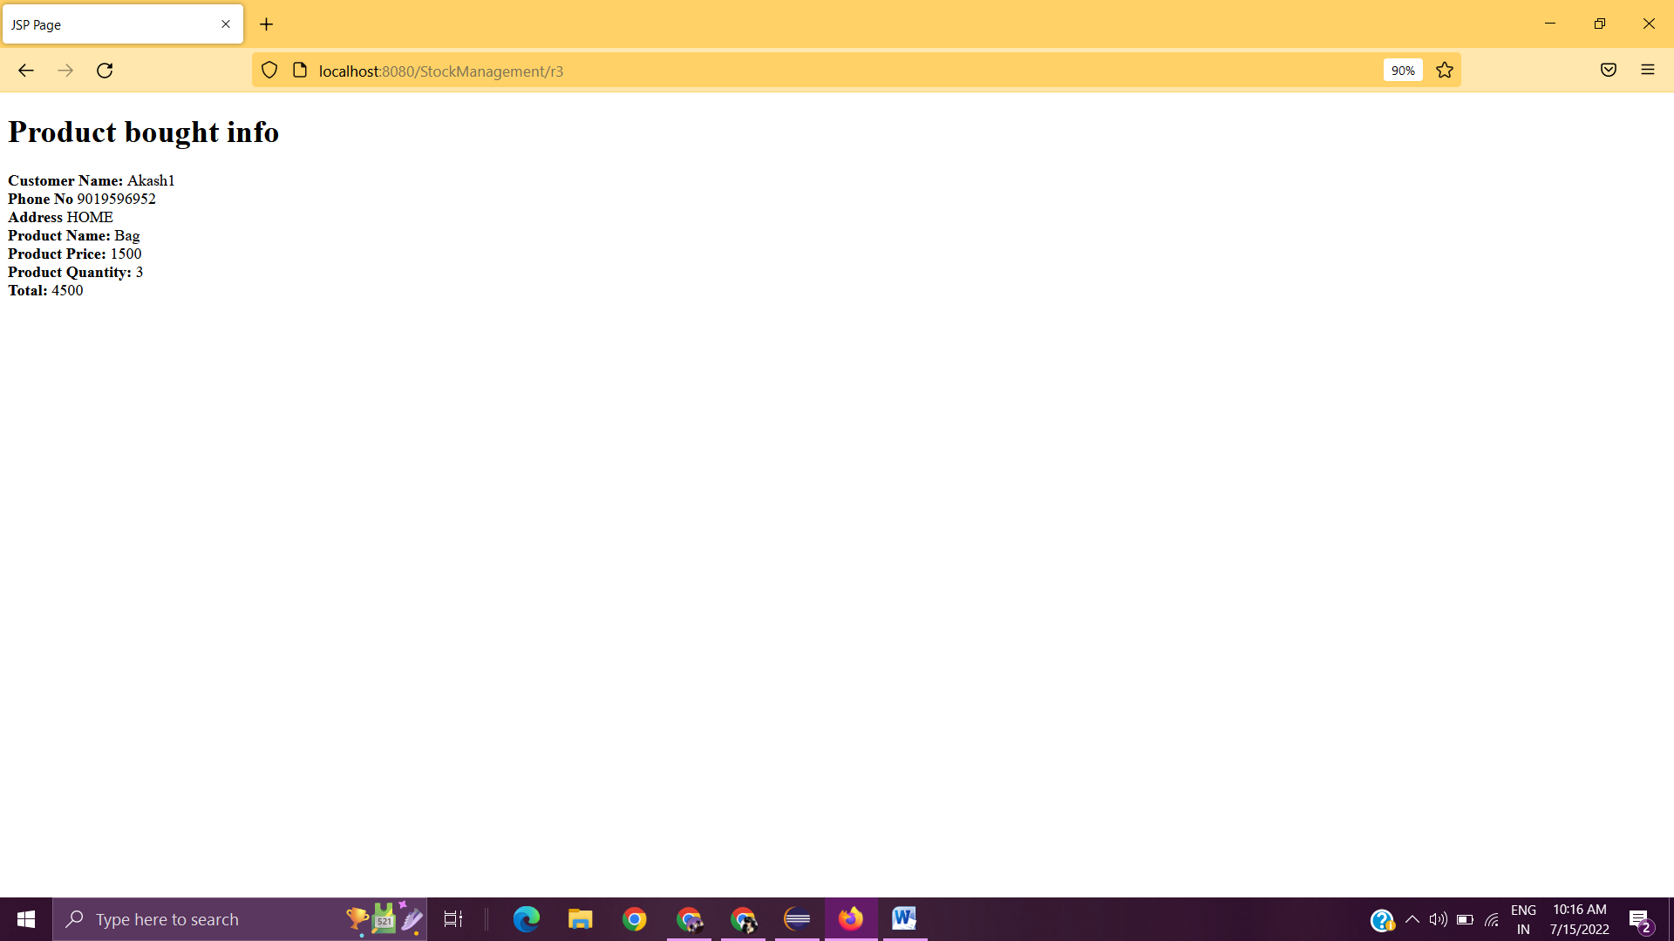

**Page**| 19

Stock Management Project|

**Fig 6.6 Invoice**

This form gives us the proper details of the customer and products bought and generates the bill.

**Future scope:-**

❖ Stock Management System (SMS) is targeted to the small or medium organization which doesn't have many warehouses only to those

organizations that have a single power of authority. Some of the scope are:

➢ Only one person is responsible for assigning the details or records. It is security driven.

➢ Store houses can be added as per the requirement.

**Page**| 20

Stock Management Project|

❖ This application is used to show the stock remaining and details about the sales and purchase. It gives the details about the stock on daily basis, weekly based and monthly based.

**Advantage of Stock Management System:-**

● Cost saving

● Saves time

● Increased efficiency

● Warehouse organization

● Data Security

**Disadvantage of Stock Management System:-**

● Expensive

● Complexity

**CONCLUSION:**

Stock Management System is a simple desktop based application basically suitable for small organizations. It has basic items which are used for the small organization. Our team is successful in making the application where we can update, insert and delete the item as per the requirement. This application matches for small organizations where there is a small limited if warehouse. Though it has some limitations, our team strongly believes that the implementation of this system will surely benefit the organization.

**Page**| 21

Stock Management Project| **Page**| 22

Stock Management Project| **Page**| 23

Stock Management Project| **Page**| 24

Stock Management Project| **Page**| 25